Sheela Ahmed

David Long

Intro to Imaging and Video Systems: Homework 4

April 6, 2016

1. Defining an image as “sharp” is a subjective impression based on the crispness and focus throughout an image [1]. Sharpness indicates the visual perception of the clarity within an image that is associated with acutance and contrast. The more contrast there is along edges of objects in an image, the more we perceive that area as sharp, which is where acutance and sharpness are related. In a way, sharpness depends on the level of acutance in the image, where a higher acutance means the image is sharper and a lower acutance means the image is blurrier.

Acutance is the quantitative evaluation of the contrast along the edges of an object in an image. In the Modulation Transfer Function graph, the acutance is equivalent to the area under the curve, which shows that it takes into account the sensitivity of the human visual system at various spatial frequencies to make the desired changes [1]. The main difference between sharpness and acutance is that acutance is the objective evaluation of the tonal differences along the edges in an image, while sharpness is the subjective evaluation that is a visual perception of the acutance determined by the human visual system.

Resolving Power is, in terms of optics, the ability to produce separate images of objects that are close together and distinguish them as being separate rather than only one point [2]. In imaging, resolving power is a subjective evaluation of the finest and smallest detail within an image [1]. The more detail perceived by the human eye, the higher resolving power that image has. Overall, resolving power is essentially the amount of fine detail that is noticeable when observing an image, and the measurement of that fine detail is the resolution.

Resolution represents the quantitative measurement of the resolving power, defined by the size of the smallest detail in an image. The limiting resolution, in relation to the Modulation Transfer Function graph, is the spatial frequency at which the MTF curve reaches its specified minimum value [1], which, in other words, is when the contrast measured from the subject to the image isn’t modulated in any way, allowing the human visual system to perceive all the fine detail within the image. Resolution and resolving power are related similarly to sharpness and acutance in that resolving power is the subjective perception of fine detail and resolution is the objective measurement of that detail within an image.

1. 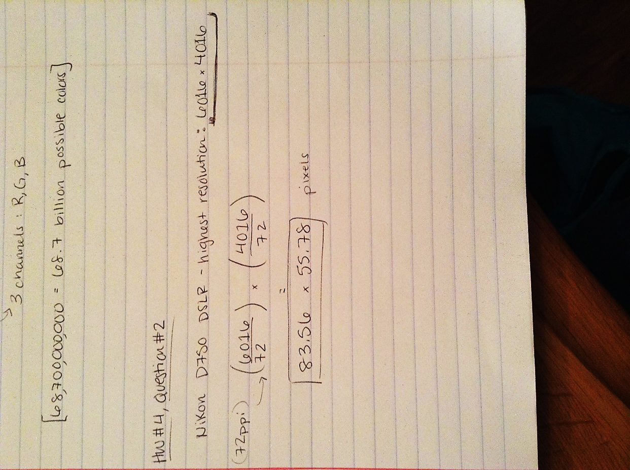The highest resolution of the Nikon D750 is 6016 x 4016 pixels, and the display resolution is 72ppi. To find the screen size, the dimensions of the highest resolution are divided by the display resolution, which in this case is 72 pixels per inch. The screen would have dimensions of 83.56 x 55.78 pixels in order to display a full size image from the camera.
2. 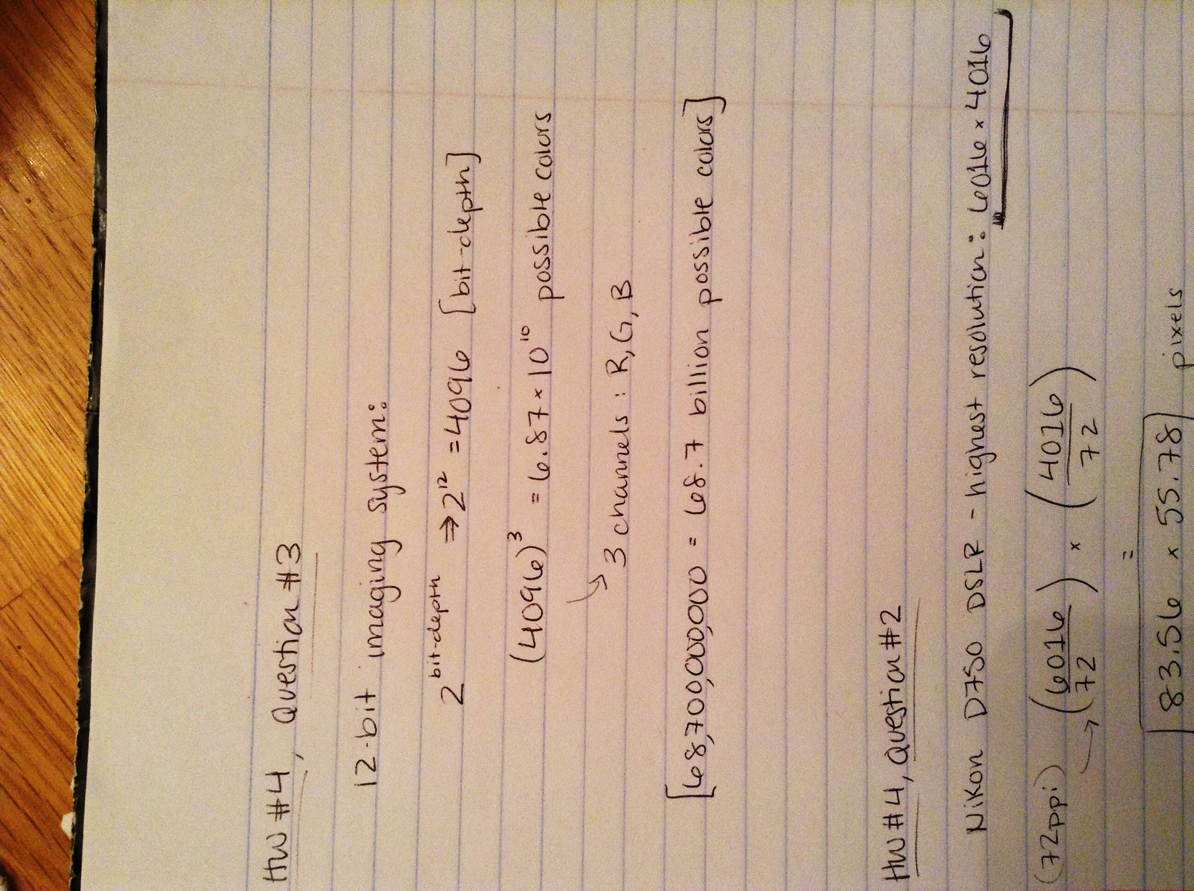With a 12-bit imaging system, there would be approximately 68.7 billion possible colors represented. The first step is to find the bit-depth which is a power function of base 2. Then, since there are three channels for red, green, and blue, the bit-depth is raised to the 3rd power to reach the total number of possible colors, which is 68.7 billion.
3. One aspect ratio was created by Mike Todd known as the Todd AO, which used a 70mm film format so create an aspect ratio of 2.20. It was first utilized in the film *Oklahoma* in 1955 and later in *Around the World in 80 Days* in 1956*.* Another recent film that utilized the 2.20 aspect ratio was *Tomorrowland*, which was released in 2015 [4]. The main goal of Todd AO was to recreate the “Cinerama” experience, but with only one camera, so the films were shot on 65mm negative and, with some space for soundtracks, were then printed onto 70mm print stock for projection. This extra space left for sound is one reason why Todd AO has been a promising system to use since it was created. Over the years, the company has grown substantially and now has a separate section for sound control, with multiple facilities made solely for sound mixing. Numerous Academy Awards have been given for “Best Sound Mixing” for films that utilized the Todd-AO sound mixing systems [8]. In addition, the original version used a framerate of 30 frames per second, which, since it’s faster than the standard 24 frames per second, helped the film appear steadier with less flicker visible to the human eye. Although this was only used for the first few films shot using the system, the idea itself was what helped Todd-AO succeed. Using an aspect ratio of 2.2 seems promising for widescreen formats, and since it was made in succession to Cinerama, the larger ratio helps create the same illusion.

The Ultra Panavision was another [system] that used a 65mm negative to capture frames along with an integrated anamorphic lens, but with an aspect ratio yielded to 2.76. Panavision, a motion picture equipment company, collaborated with MGM to create the system – which is why it’s also been referred to as MGM 65 and Panavision 65. The aspect ratio has only been used in very few films, one of the most famous being *Ben-Hur* [6]. However, director and writer Quentin Tarantino decided to use the aspect ratio in his most recent film, *The Hateful Eight*, which caused some theaters to retrofit anamorphic lensed 70mm analog film projectors to display the movie as Tarantino had intended it to be [7].

Works Cited

[1] “MTF” PowerPoint given during lab, April 1, 2016. Slide 5.

[2] Dictionary.com "resolving power," in *Dictionary.com Unabridged*. April 05, 2016. <http://www.dictionary.com/browse/resolving-power>

[3] “Sharpness: DXOMark Measurements for Lenses and Camera Sensors”. DXOMark. <http://www.dxomark.com/About/In-depth-measurements/Measurements/Sharpness>

[4] *Tomorrowland*. IMDb. <http://www.imdb.com/title/tt1964418/technical?ref_=tt_dt_spec>

[5] “The Changing Shape of Cinema: The History of Aspect Ratio”. FilmmakerIQ. 2016. <http://filmmakeriq.com/lessons/the-changing-shape-of-cinema-the-history-of-aspect-ratio/>

[6] “Panavision”. Santa Barbara City College, School of Media Arts. <https://soma.sbcc.edu/users/davega/filmpro_170/FILMPRO_170_Reference_Notes/PanaVision/Panavision.doc>

[7] *The Hateful Eight*. IMDb. <http://www.imdb.com/title/tt3460252/?ref_=nv_sr_1>

[8] Crisp, Andy. “Sound Mixing: Audio Post-Production at Todd-AO Studios”. Laguna Beach Unified School District. 2009. <http://www.saddleback.edu/uploads/cte/collaborative/media/Crisp-Externship.pdf>